DATE: 28.02.2020
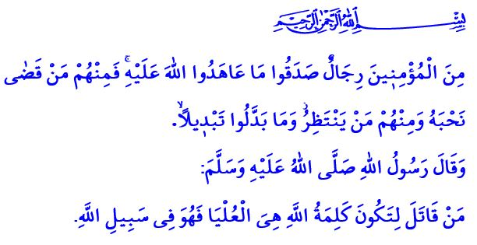
OUR FIGHT, AND SPIRIT OF UNITY AND SOLIDARITY IN THE CAUSE OF ALLAH
Honorable Muslims!
In the verse I have recited, Allah the Almighty states, “Among the believers are men true to what they promised Allah. Among them is he who has fulfilled his vow [to the death], and among them is he who awaits [his chance]. And they did not alter the terms of their commitment by any alteration.”
In the hadith I have read, the Prophet Muhammad (saw) says, “He who fights that Allah's word should be superior fights in Allah’s cause.”
Dear Believers!
We as a nation are facing great challenges and going through heavy tests today, just as we did in the past. Today, too, we are putting up a restless fight against those powers, who has their conscience blinded and lost their mercy and humanity, and aims to remove us from the stage of the history, just as in the Battle of Gallipoli and the War of Independence in the past. Today, too, we, together with each and every individual of our noble nation regardless of man, woman, young, or elder, will not let anybody pull our national flag down the post, silent our adhans, or tread on our homeland.
It is the unshakable faith we have in Allah (swt) that will allow us to come out as victorious. It is our unconditional love for our homeland, our adhan, our national flag, and our independence. It is the desire to fall martyr in the cause of Allah or live on as a veteran that we have deep in our hearts. This is such a great faith and love for homeland that Allah the Almighty gives the good news to those who, with this great love, have sacrificed their lives in this cause, “And never think of those who have been killed in the cause of Allah as dead. Rather, they are alive with their Lord, receiving provision, rejoicing in what Allah has bestowed upon them of His bounty.”
Dear Muslims!
Our soldiers has been and will always be standing by the oppressed against the oppressors. They are at the battlefronts for the good of the world and shield their chests for humanity. They are mobilized to rush to help of those whose rights are infringed and removed from them.
Our soldiers place faith in the following verse and stand firm by the side of the truth against the falsehood,
وَقُلْ جَٓاءَ الْحَقُّ وَزَهَقَ الْبَاطِلُۜ اِنَّ الْبَاطِلَ كَانَ زَهُوقاً
“And say, ‘Truth has come, and falsehood has departed. Indeed is falsehood, [by nature], ever bound to depart.’”
Our soldiers run from victory to victory with the heartfelt committment to the verse,
وَلَا تَهِنُوا وَلَا تَحْزَنُوا وَاَنْتُمُ الْاَعْلَوْنَ اِنْ كُنْتُمْ مُؤْمِن۪ينَ
“So do not weaken and do not grieve, and you will be superior if you are true believers.”
They say “Stop!” to the graceless attacks of the enemy, satisfying the Prophet Muhammad’s call,
جَاهِدُوا بِأَيْدِيكُمْ وَأَلْسِنَتِكُمْ وَأَمْوَالِكُمْ
“Fight in the cause of Allah with your wealth and lives.”
Dear Believers!
Yesterday an atrocious attacked targeted our soldiers who were mobilized to bring peace to the terror-torn geographies, hope to those whose hopes were aimed to be destroyed, and stability to those whose lives were set upside down. Our pain is unbearable, our heart broken. May the noble souls of our martyrs be blessed by Allah (swt). May Allah bless our nation with patience for our losses. May Allah bless the injured with a speedy recovery. May Allah never ever let any such sorrow hit us.
Let us not forget this important point that there is no fight out of which we cannot come out as victorious as long as we as a nation clamp tightly together with each other around the values that make us ‘us’. There is no heinous attack that we cannot bear against or no victory that we cannot win as long as we keep alive our spirit of unity, solidarity, and brotherhood. There is no doubt that with the help of Allah, the plans of treachery will be disrupted, the traps and cheats of the oppressors will become thorn in their own sides. Today, too, it will be our noble nation standing by the truth and the right that will be victorious just as in the past. As expressed in the Holy Qur’an, سَيُهْزَمُ الْجَمْعُ وَيُوَلُّونَ الدُّبُرَ “Their assembly will be defeated, and they will turn their backs in retreat.”
Honorable Muslims!
Let us open our hands and hearts to pray Allah in this hour when prayers are accepted. Let us all beg our Exalted Lord (swt).
O Allah! Bestow Your help and victory upon our heroic army, and Your grace and barakah upon our heavenly homeland!
O Allah! Bless our martyrs with Your mercy, our veterans with Your grace, and our nation with Your compassion!
O Lord! Do not let our adhans be silenced! Do not let anybody or anything divide our homeland! Do not let anybody pull our flag down the pole, o Allah! Do not make us bow down before anybody! Protect our soldiers from any kind of evil and harm!
O Lord! Strengthen our unity and solidarity and increase our patience and resoluteness! Ease our pains and griefs and bless our hopes with victory! Amin!

Ahzab, 33/23.
Bukhari, Tawhid, 28
Al-i ‘Imran, 3/169-170.
Isra, 17/81.
Al-i ‘Imran, 3/139.
Nasa’i, Jihad, 48.
Qamar, 54/45. General Directorate of Religious Services

